**Opportunity**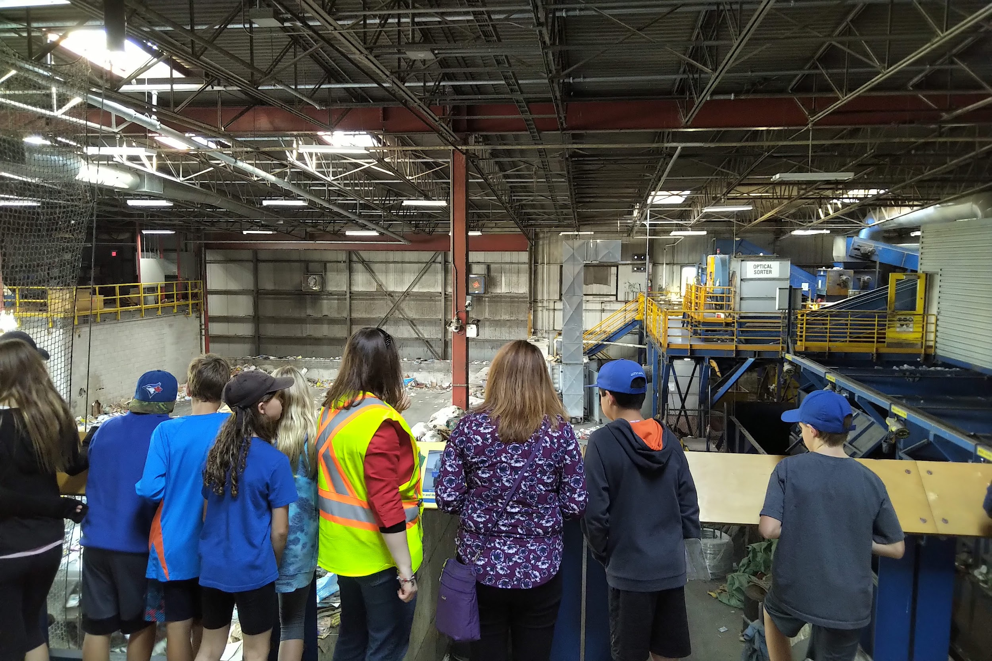

**Problem summary**

In our community there are issues with recycling in public spaces:

* Sometimes only garbage cans are available so everything is landfilled
* Some places have garbage and recycle bins but they are commonly misused

We know this is occurring in many communities across Canada.

**Solution summary**

* Make a sorting machine to sort waste into recycling or garbage using artificial intelligence and deep learning
* Implements the three Vitruvian principles: strength (final product will have a durable design), beauty (keeping our community spaces litter-free) and usefulness (makes waste management easier)
* Helps to solve the key issue of contamination in recycling cited by five Ontario municipalities in our research
* Advantage of our Smart Sorter over humans is it will remember and update rules better than any human through deep learning and can connect to the Region for updates

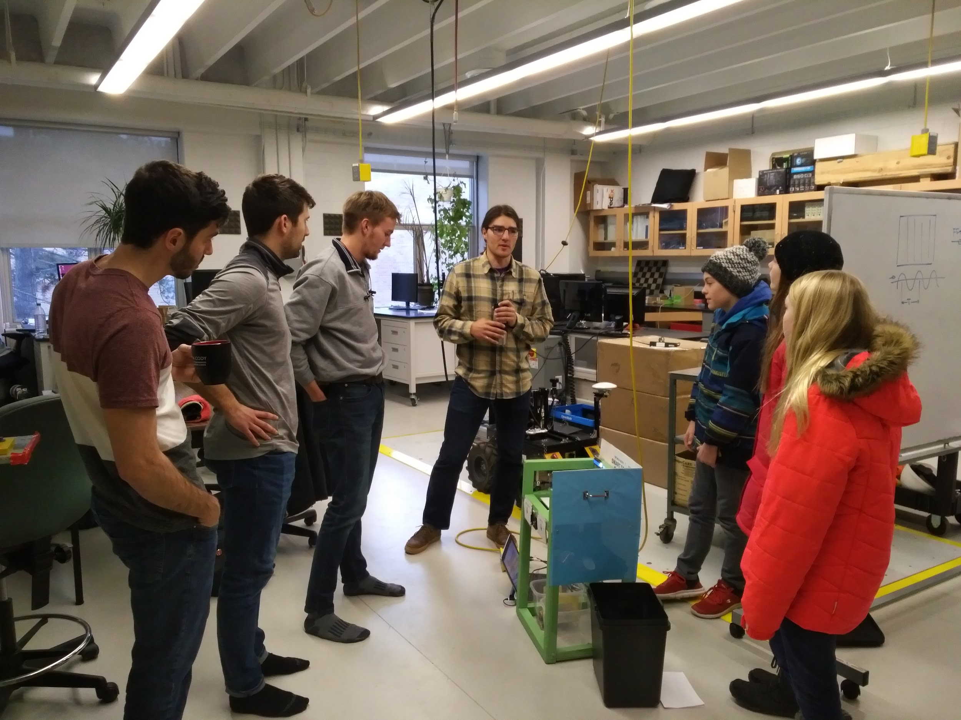

**Experts Consulted**

* Evan McLaughlin, UW Engineering ,
  + Deep Learning AI, Masc
* Dirk Friesen, UW Engineering Department,
  + Hardware Specialist
* Steve Phillips, UW Engineering Department,
  + Robotics, Phd Candidate
* Nick Charron, UW Engineering Department,
  + Robotics
* Veronica Naas, Region of Waterloo
  + Waste Management
* Elizabeth Hueftlein, Hahn Plastics

*“It was awesome to see the work you have all been doing on your project. We were impressed with your prototype and see a lot of potential in your ideas. Please don't hesitate to contact us again if you have any follow-up questions. We are more than happy to answer anything that may have been unclear.*

*It was easy making it understandable. From listening to Connor, Beth, and Brooklyn talk about the prototype it was clear that The Wild Goats Robotics Team has some very knowledgeable team members! I have no doubt you can all work in a lab like ours one day.”*

Evan McLaughlin, UW Engineering Department, Deep Learning AI

**Strategic Implementation Plan**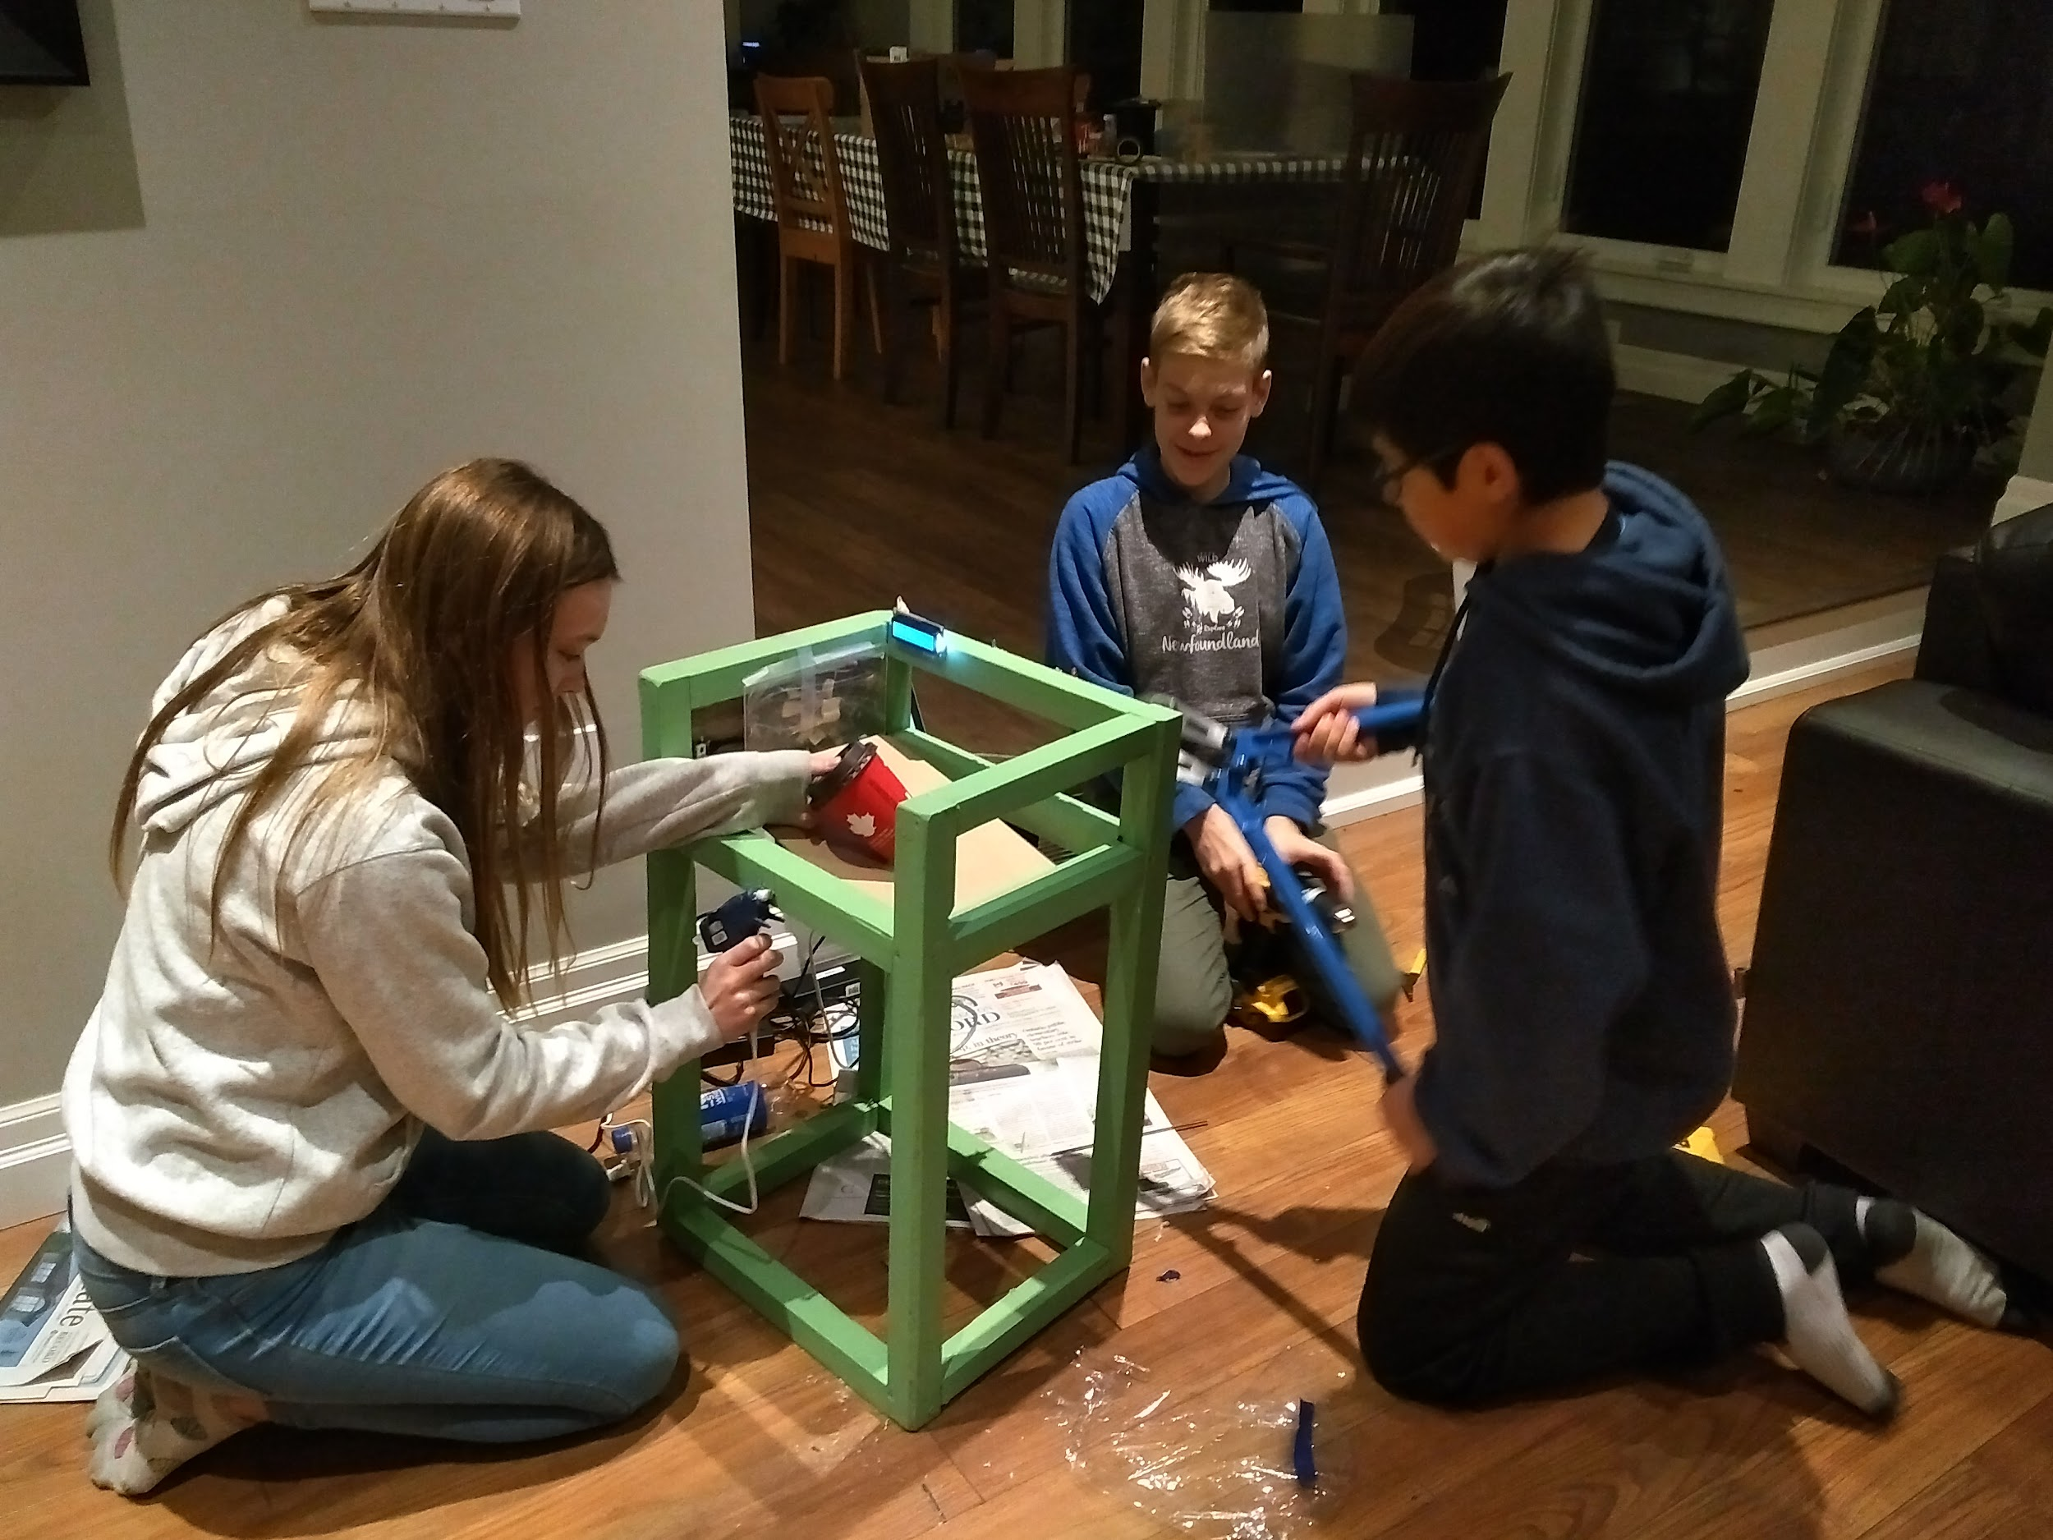

**Hardware**

* Retrofit to current garbage cans
* Layered platforms for more bins to sort
* Close in top and sides to weatherproof
* Add a wifi module for program updates and deep learning
* Recommended Particles who makes Wifi and Bluetooth chips at hobbies grade which are inexpensive add on chips Arduino
* Use hologram
* Remove as many moving parts as possible, such as the coupler and belt to one shaft and put a motor in wood to not stick out
* Use aluminum extrusions or plastic lumber to make stronger, weatherproof and longer-lasting
* Use wire clips instead of so many wires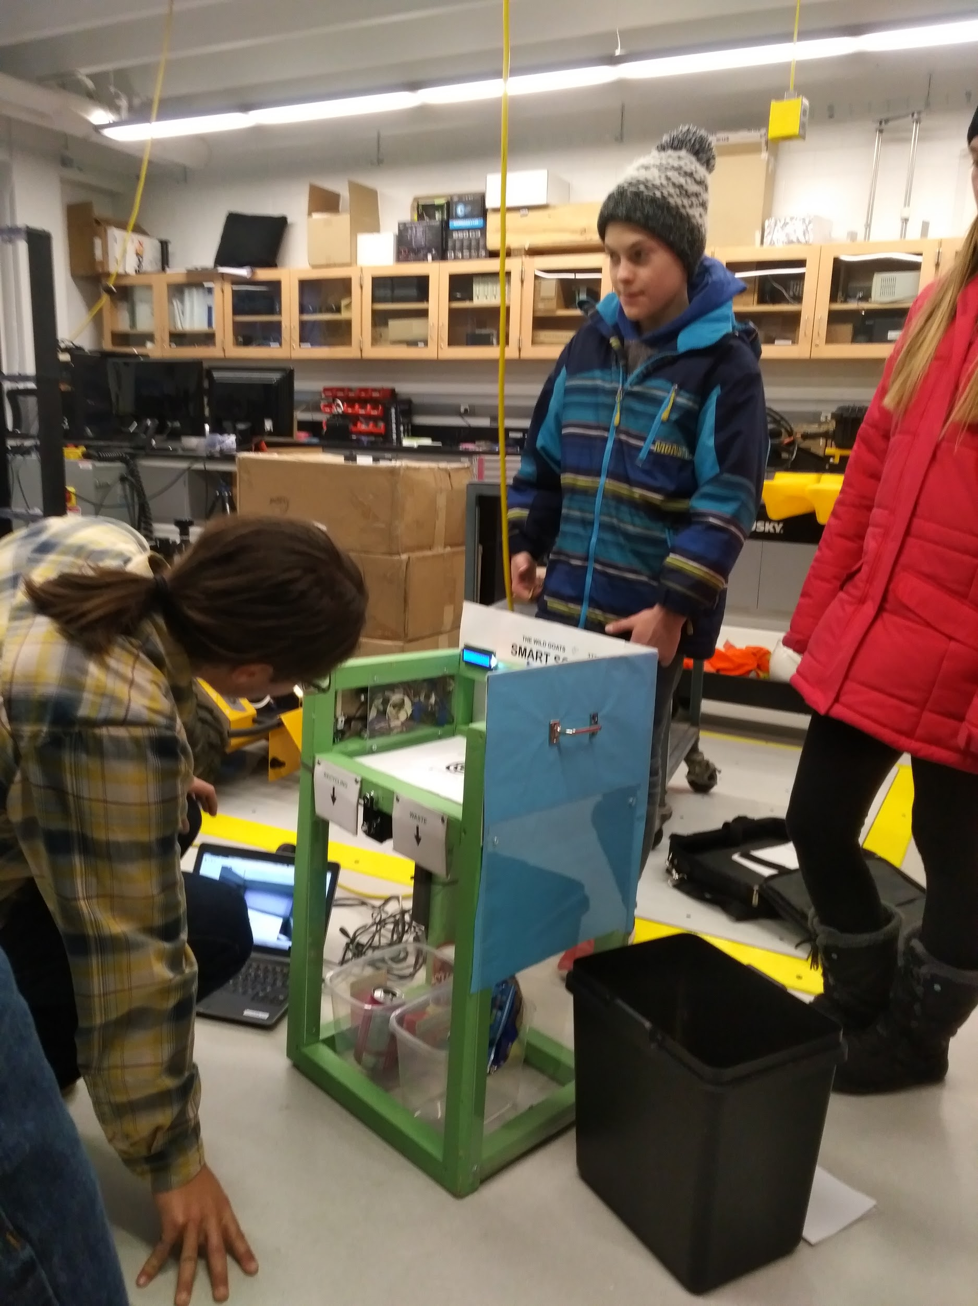
* 3D mount for all electronics for greater stability
* Laminate flipper to make it waterproof
* Battery or solar-powered

**Imaging**

* Add another camera at a different angle for increased accuracy
* Cost of current camera would decrease, as we would buy in mass
* If two different items put on at once put alarm and notice on the screen saying one item at a time
* Motor strength should be stronger
* Add a weight sensor to determine if the containers have food or drinks in it if it does an alarm goes off

**Software**

* Use Infedia which has a module to replace our laptop
* Add deep learning to recognize items over time
* Add Altium circuit maker software for microcontroller and circuit board
* Use “cad” tool to design a circuit board
* Set up an “off the air” wifi connection that weekly looks for updates from the Region of Waterloo
* Make a program open loop to make the flipper flat after each sort
* Close loop control system on the motor using the number of ticks to measure how much it turned to determine how far it needs to go back to be level
* Make anti-theft with a GPS tracker

**Other**

* Use students for deep learning on prototypes - they put something in and say what it is
* The next step is to make 10 prototypes to do testing for production
* Make 10-100 prototypes to put in schools and have kids put stuff in and press and button to say what it is to make mass training deep learning - this would make developing a large database of learning very fast
* They think the cost could be the same or less than two normal garbage cans

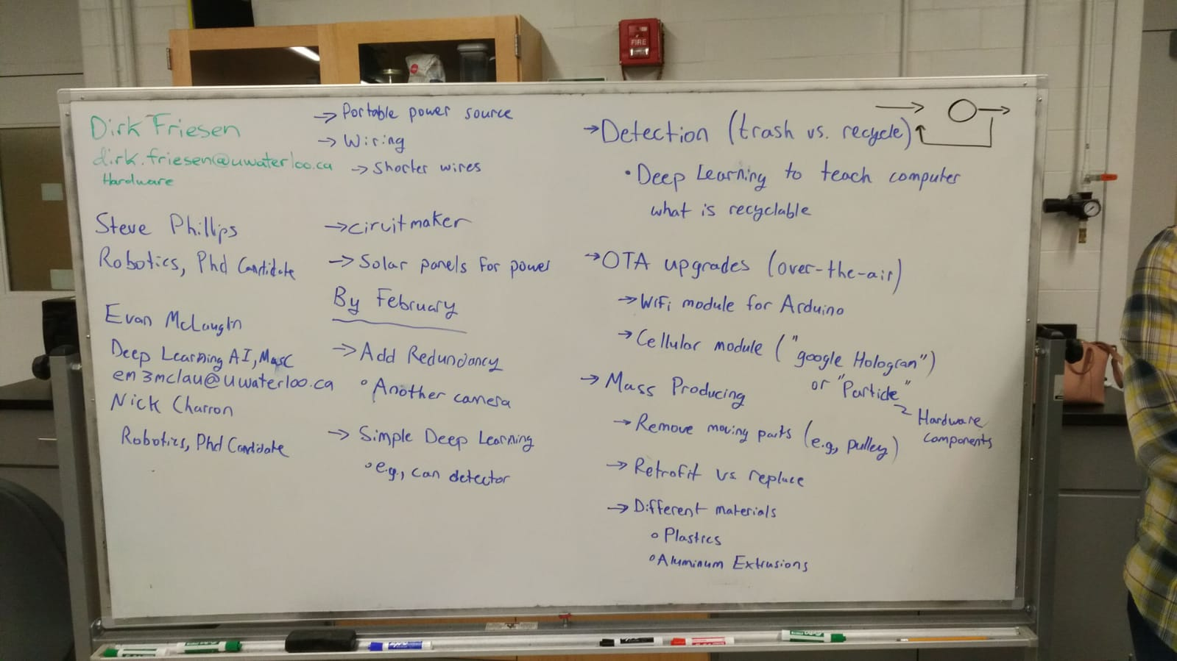

**Target market**

The next step is to make 10 prototypes to do testing for production. Then make 10-100 prototypes for a test group to mass train deep learning. As part of our prototype testing we would approach the following organizations:

* Paradise and District Lions Club for their local community parks
* Township of Wellesley for township buildings and their parks
* University of Waterloo and Wilfrid Laurier University

**Competitors**

We know PHD student from the university of Toronto are also creating a sorting prototype.

We don’t know of any sorting machine on the market today. 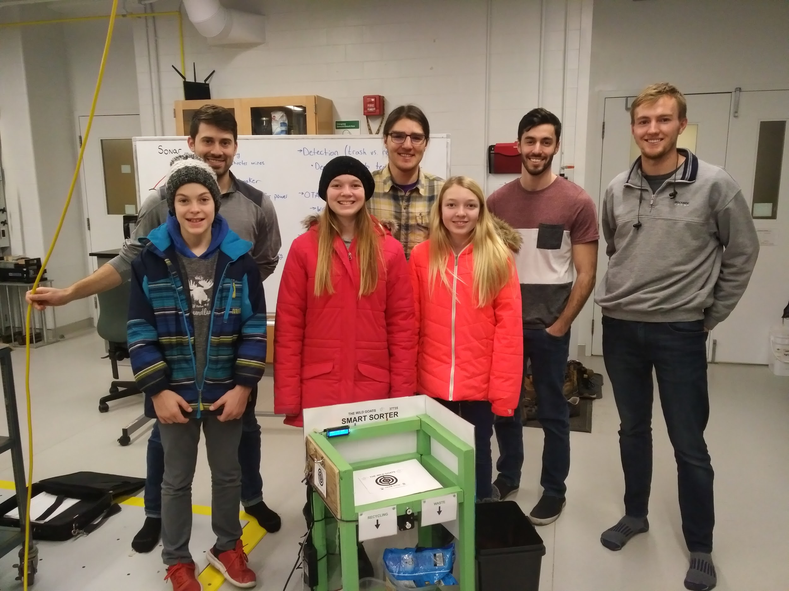

**Supplies needed for production**

* Plastic lumber
* Pixy2 Camera
* Arduino Uno Board
* 2 stepper motors
* Plexiglass
* Thin metal rod
* Arduino screen
* Circuit board (will replace wires and breadboard on prototype for production. Will make board more durable and repeatable)

**Production Cost**

* Prototype cost was $151.00
* Target mass production cost at 25% of prototype (under 40 dollars.) We plan to create the sorter to fit on to current garbage bins, to not create any more waste.